# Bansilal Ramnath Agarwal Charitable Trust’s

Vishwakarma Institute of Technology, Pune-37

*(Anautonomous Institute of Savitribai Phule Pune University)*

**

**Department of Multidisciplinary Engineering**

|  |  |
| --- | --- |
| **Division** | ET D |
| **Batch** | Batch 1 |
| **GR-no** | 12111257 |
| **Rollno** | 08 |
| **Name** | Sahil Ashok Sawant |

**Title:** Design and Execute "SELECT" queries using conditional, logical, like/not like, in/not in, between...and, is null/is not null operators in where clause, order by, group by, aggregate functions, having clause, and set operators. Use SQL single row functions for date, time, string etc

**Title:** Design and Execute "SELECT" queries using conditional, logical, like/not like, in/not in, between...and, is null/is not null operators in where clause, order by, group by, aggregate functions, having clause, and set operators. Use SQL single row functions for date, time, string etc

**Description:**

*GroupBy Clause:*

The GROUP BY clause is used in MySQL queries to group rows based on one or more columns

Eg : SELECT * destination FROM flights group by class;

*Distinct Keyword:*

The DISTINCT keyword is used to retrieve only unique values from a column or set of columns in a table.

SELECT DISTINCT destination FROM flights;

*Aggregate Functions:*

Aggregate functions are used to perform calculations on a set of values and return a single result. Examples of aggregate functions include COUNT, SUM, AVG, MIN, and MAX.

SELECT AVG(price) FROM flights;

*Set Operations:*

Set operations are used to combine results from two or more SELECT statements. The common set operations in MySQL are UNION, UNION ALL, and INTERSECT

*Nested Queries:*

Nested queries, also known as subqueries, are queries that are embedded within another query. They can be used to perform complex queries that require multiple steps.

*Where clause :*

The WHERE clause is used to filter rows based on a specific condition. It is applied to the rows in the table before any grouping or aggregation occurs.

*HAVING clause :*

The HAVING clause is used to filter groups based on a specific condition.It is applied after the GROUP BY clause in a query that includes grouping or aggregation.

SELECT flight_id, destination, COUNT(*) AS num_seats, AVG(price) AS avg_price

FROM flights

WHERE price > 500

GROUP BY flight_id, destination

HAVING num_seats > 10;

**Screenshots/Output:**

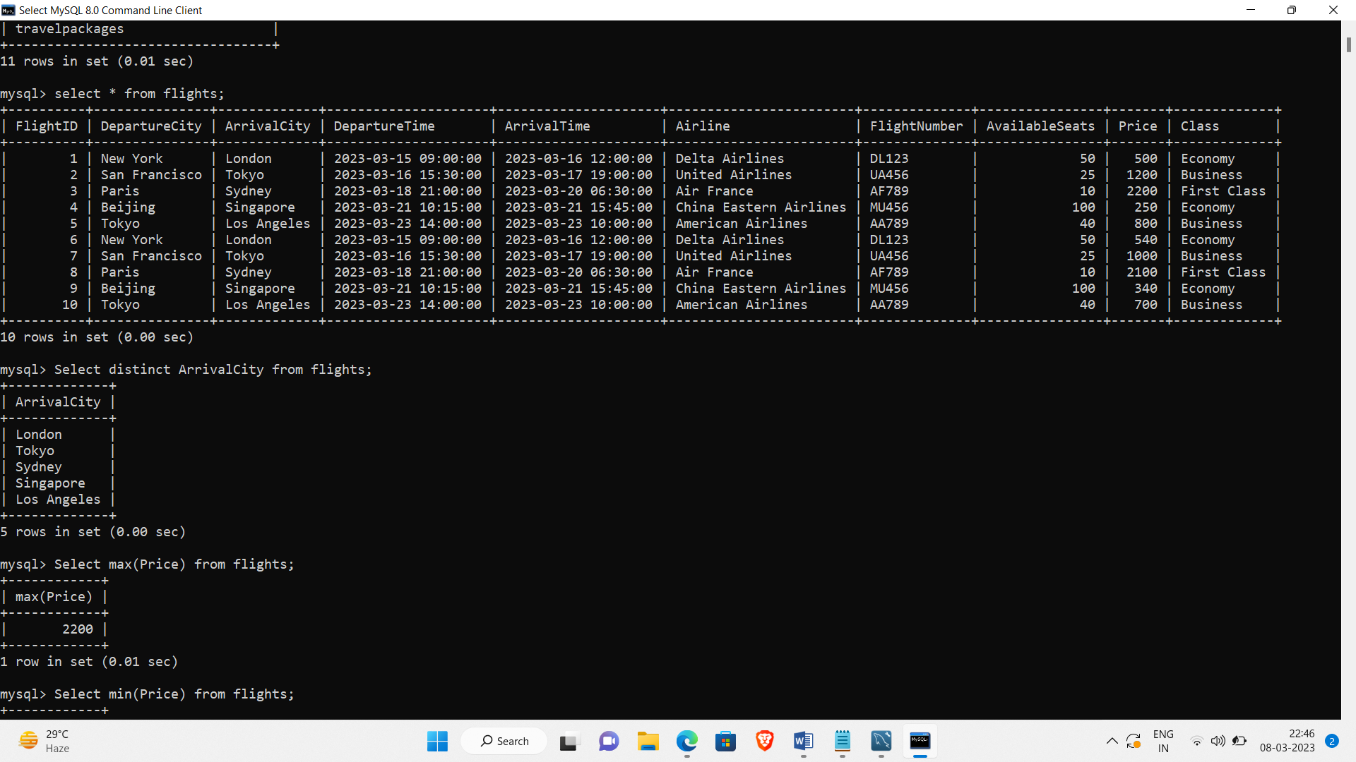

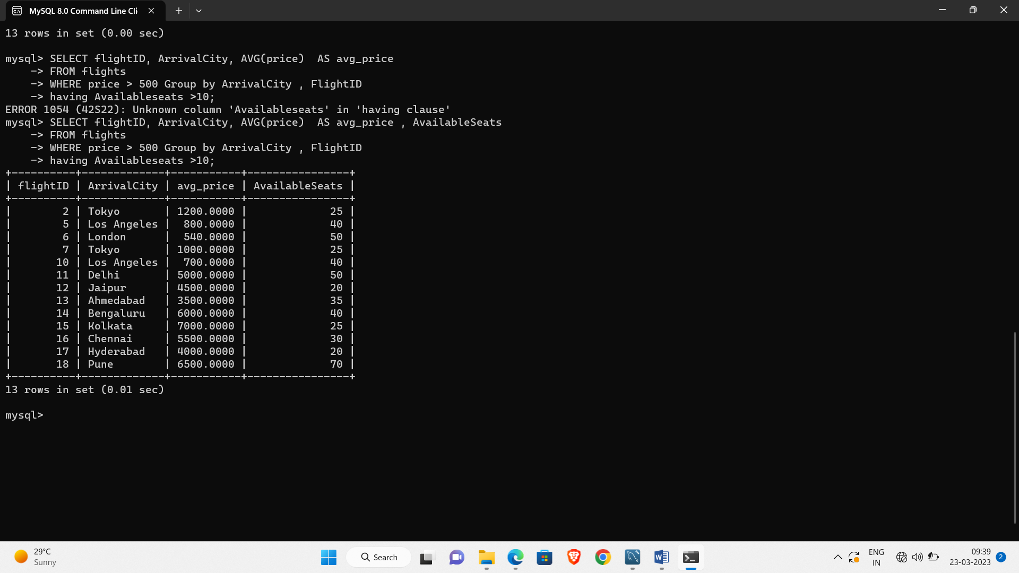

**Aggregate functions and using where clauses:**

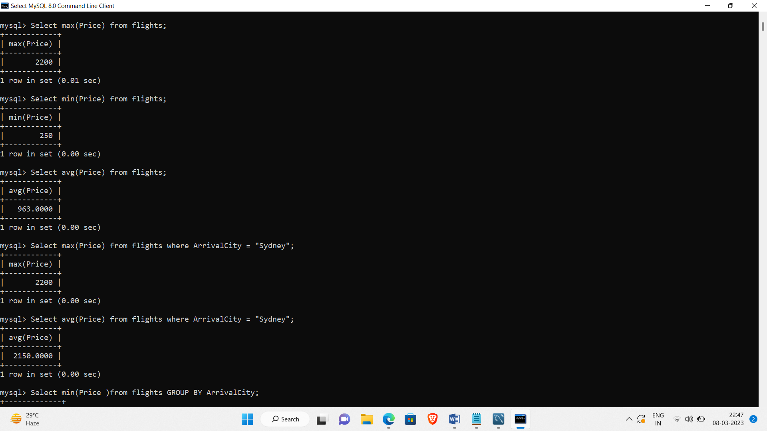

**GROUP BY ,Aggregate functions , where clause**

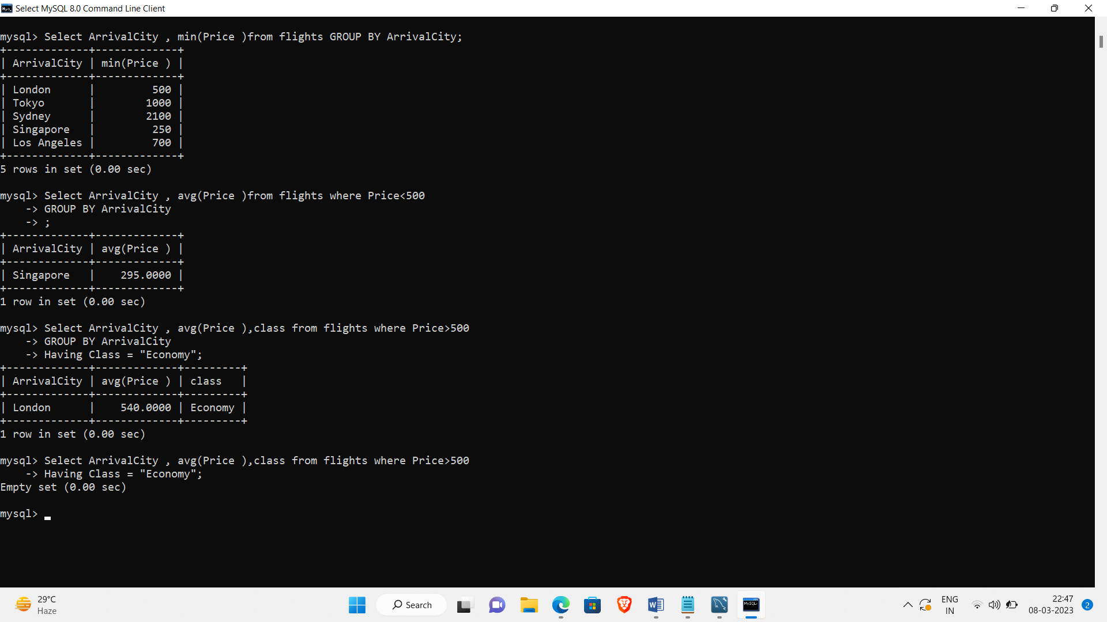

**Set Operations : two tables :**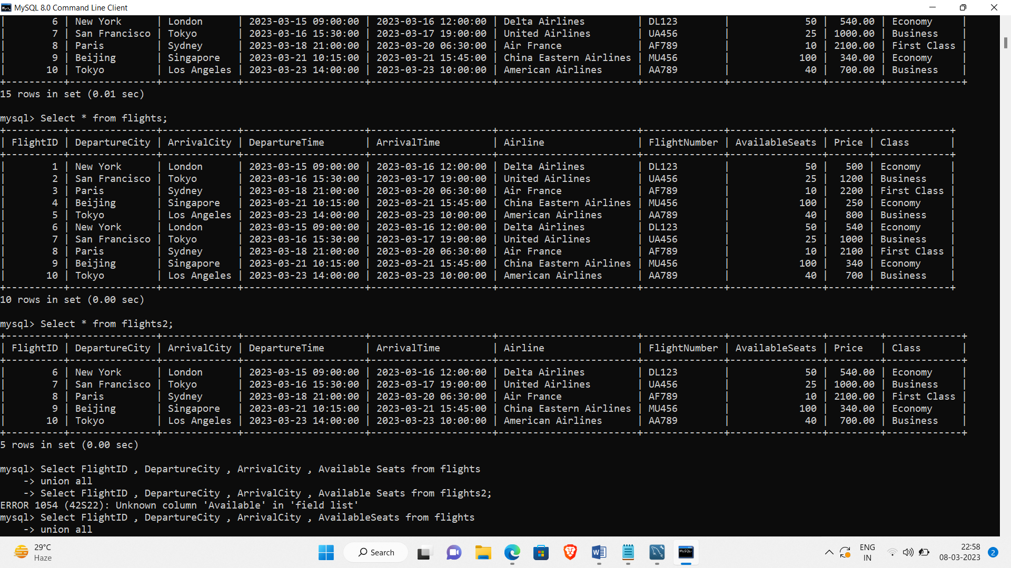

**Union All – set operartions**

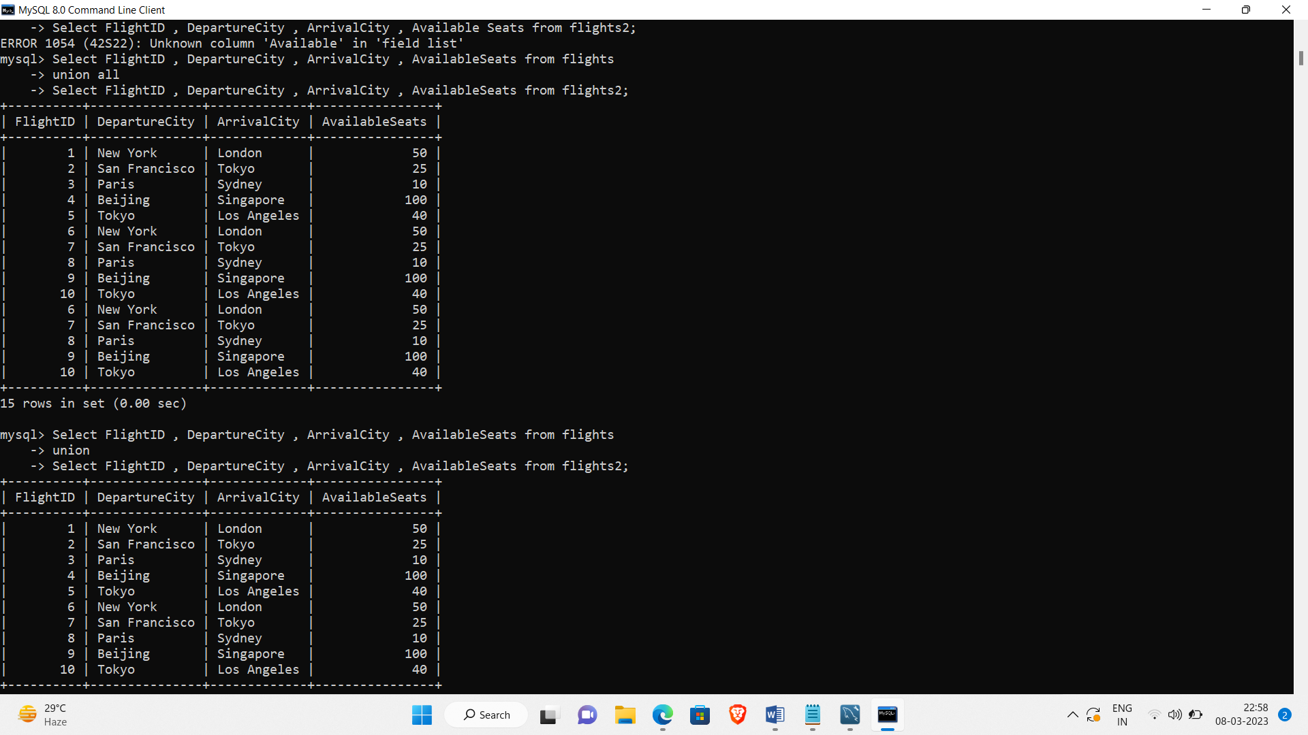

**UNION AND INTERSECT - SET OPERATIONS**

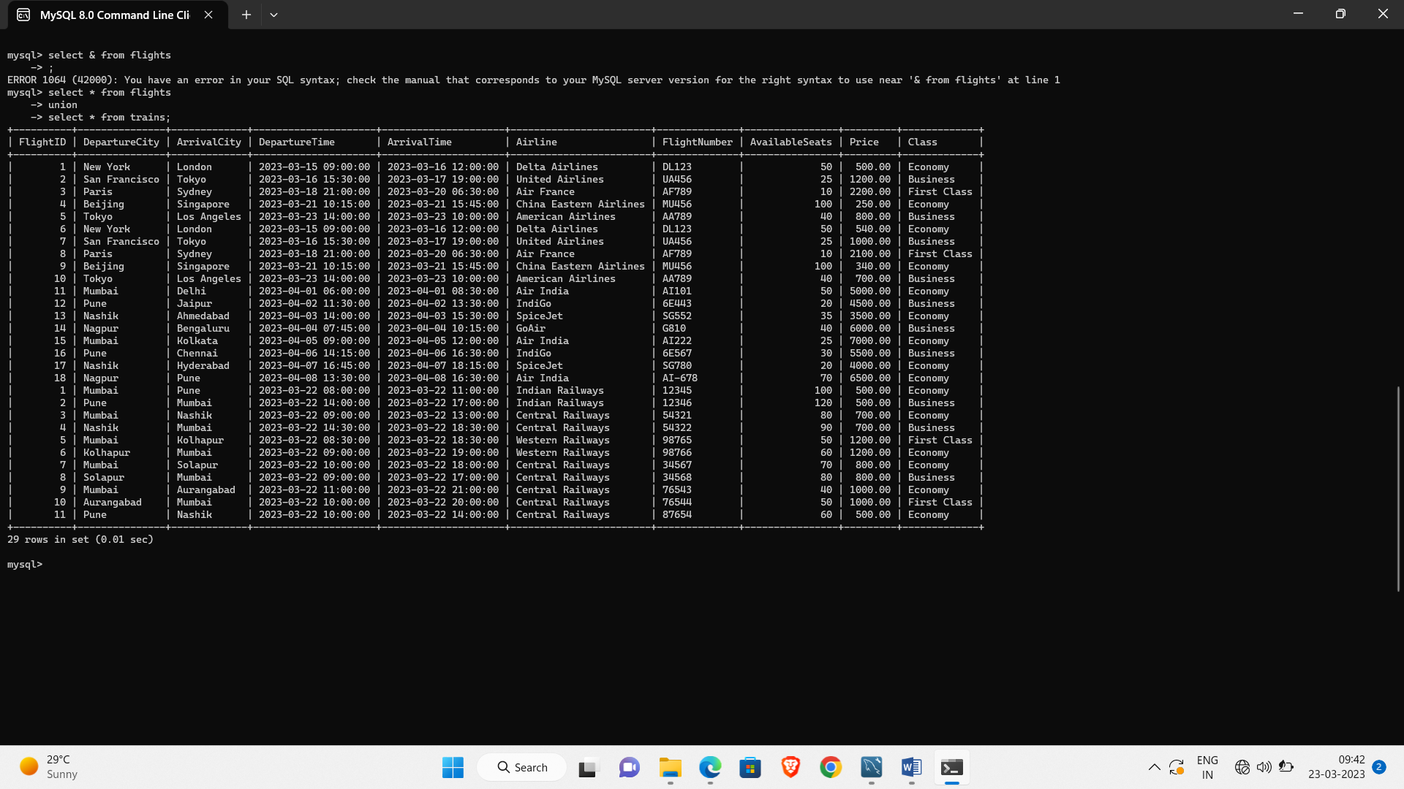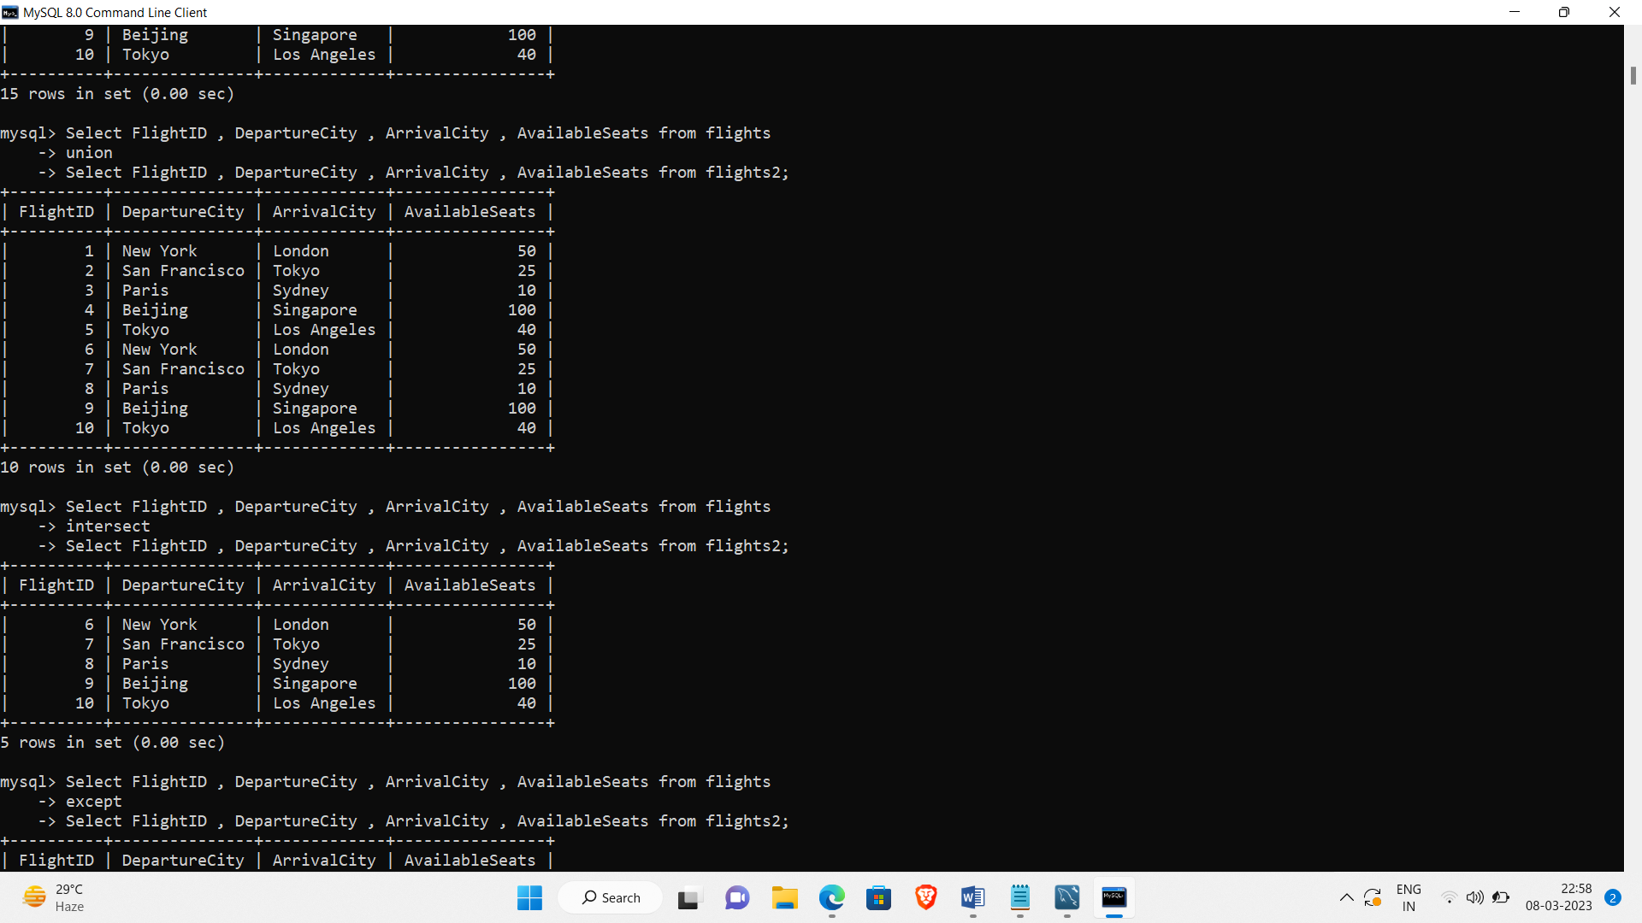

**Except – SET operation**

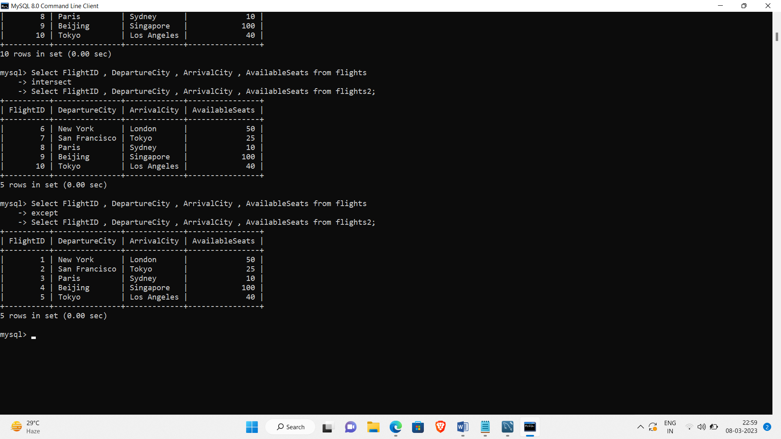

**Distinct Keyword:**

